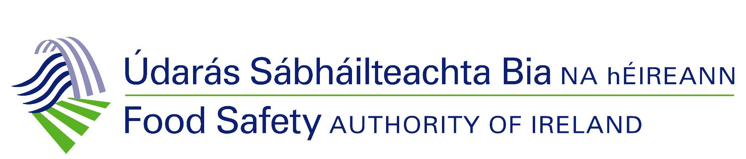

Data Subject Access Request (DSAR)

(Please type or write in block capitals)

This form may be completed if you wish to request a copy of personal data held by the Food Safety Authority of Ireland (FSAI) under the General Data Protection Regulation (GDPR) and Data Protection Act 2018.

Please complete all fields.

- Details of the data subject

First name: Surname:

Address:

Telephone:

Email:

- Details of request
In this space, please provide details of the personal information requested. Please state as accurately as possible the dates the information refers to, your exact name and address at the time the information and/or records were created

- My preferred form of access is (please tick one):

Post
Email

- Identification
Before you are given access to personal information relating to yourself, you are required to provide:

- a copy of your identification bearing your full name and photograph (for example, passport, driver’s licence, etc.)
- proof of address to which the materials will be sent (for example, the top of a utility bill bearing both your name and address). This must be less than six months old

If you are requesting personal information on behalf of the data subject, signed proof of direct authorisation must be provided with this form.

- Is there any further information you would like to add?

- Signature
I declare that all the details I have given in this form are true and complete to the best of my knowledge.

Signature of applicant: ______________________ Date: ____________

Once complete, please send this form to either of the following addresses:

By post | Data Protection Officer  Government and Information Unit  Food Safety Authority of Ireland  The Exchange  George’s Dock  D01 P2V6  Dublin 1
By email | DPO@fsai.ie

